**Shri Shamrao Patil (Yadravkar) Educational & Charitable Trust’s**

**SHARAD INSTITUTE OF TECHNOLOGY,**

**POLYTECHNIC, YADRAV.**



***DEPARTMENT OF INFORMATION TECHNOLOGY***

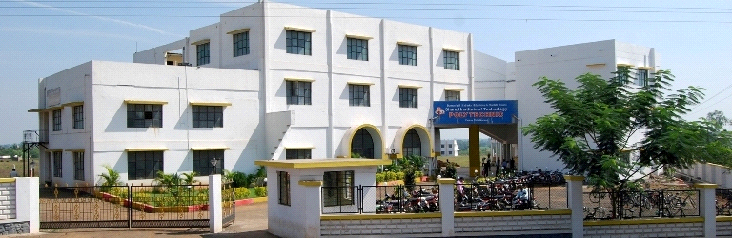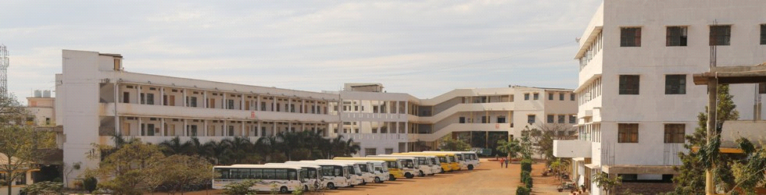

***Industrial training REPORT***

**IN**

**Web Based Application development with PHP**

**FOR**

**T.Y I.T 2020-21**

A

Project Report

On

**“DEVELOP AUDIO PLAYER USING PHP”**

Submitted in Partial Fulfillment of the requirements for the

**“DIPLOMA”**

in

**Information Technology**

to

**M.S.B.T.E. MUMBAI.**

**By**

**Name of Student Roll No.**

1. Ritika Rahul Bedmutha 13501

2. Neha Shital Bhore 13502

3. Shweta Deepak Bhosale 13503

UNDER THE GUIDANCE

**Mr. B .V. Karlatthe**

**NAME OF GUIDE**

Lecturer in Information Technology.



**S.I.T.Polytechnic, Yadrav (Ichalkaranji)**

**[2020-21]**

**Shri Shamrao Patil (Yadravkar) Educational & Charitable Trust’s**

**SHARAD INSTITUTE OF TECHNOLOGY POLYTECHNIC,YADRAV (Ichalkaranji)**



**CERTIFICATE**

This is to certify that,

**Name of Student Roll No.**

Shweta Deepak Bhosale 13503

have successfully completed the Project work entitled **"DEVELOP AUDIO PLAYER USING PHP”** under my supervision, in the partial fulfillment of the requirements for the **Diploma** in **Information Technology**, and the report submitted to M.S.B.T.E. MUMBAI for academic year 2020-2021.

Date: 10/06/21

Place: Yadrav

**Mr.B.V.Karlatthe Ms. A. A. Nirvane**

Project Guide Head of IT Department

**ACKNOWLEDGMENT**

It is my great pleasure to present the honor and sincere gratitude to my guide Mr.B.V.Karlatthe Lecturer, Dept. of Information Technology, Sharad Institute of Technology Polytechnic, Yadrav helped in joining the hands in developing each and every step of this project and for valuable guidance and constant encouragement during completion of project work. It was my privilege and pleasure to work under his valuable guidance. I am indeed gratefully to him for providing me helpful suggestions. Due to his constant encouragement and inspiration I could complete my project work.

I am very thankful to Principal, Sharad Institute of Technology, Polytechnic, Yadrav.

My grateful thanks to Ms. A. A. Nirvane, Head of Information Technology, for their valuable guidance, support and constant encouragement.

I express thanks to my family and friends for their support and encouragement at every stage of successful completion of this project work.

My sincere thank to all those who have directly or indirectly helped me to carry out this work.

**Name of Student Roll No.**

1. Ritika Rahul Bedmutha 13501

2. Neha Shital Bhore 13502

3. Shweta Deepak Bhosale 13503

**MICRO-PROJECT REPORT OF**

**“WEB BASED APPLICATION DEVELOPMENT WITH PHP”**

**DEVELOP AUDIO PLAYER USING PHP”**

**1.0 Rationale:-**

1. An MP3 player is an electronic device that can play MP3 digital audio files. It is a type of digital audio player (DAP), or portable media player.

2 .For Entertainment purpose it is very good.

**2.0 Course Outcomes Addressed:-**

1. Performs operations based on array.

2. Use form controls with validation to collect users input.

**3.0 Literature Review:-**

1. Media player is a type of application software for playing multimedia computer files like audio and video files. Media players commonly display standard media control icons known from physical devices such as tape recorders and CD players, such as play (  ), pause ( [Octicons-playback-pause.svg](https://en.wikipedia.org/wiki/File:Octicons-playback-pause.svg) ), fastforward, backforward, and stop ( [Octicons-primitive-square.svg](https://en.wikipedia.org/wiki/File:Octicons-primitive-square.svg) ) buttons. In addition, they generally have progress bars (or "playback bars") to locate the current position in the duration of the media file.

* + - Be very easy to playing music.
    - Be fully accessible on any devices.

**4.0 Actual Methodology Followed:-**

At first we created our project group and then decided the project topic. After deciding the project topic, we collected some information about it. We got some videos on the project, i.e., “**Develop a Audio player using PHP**”. Then we collected some examples that uses playbox, different buttons, image views, different function and CSS. We tried to implement the best design practices for creating Audio Player. Then we tried to implement it on Sublime Text software that is used for the coding of the programs and also run on XAMPP server. Then we created the project report. Then finally we submited the project and project report.

**5.0 Actual Resources Used:-**

|  |  |  |  |  |
| --- | --- | --- | --- | --- |
| **Sr. No.** | **Name of Resources** | **Specification** | **Qty.** | **Remark** |
| 1 | Computer system | OS windows 7 professional Processor-Intel core Duo E7500 RAM-2GB | 3 | It is used to create the project. |
| 2 | Software | 1. Sublime Text 2. Microsoft Word | 3  3 | 1. It is used for coding purpose.  2. It is used to create the project, report and proposal. |
| 3 | Server | Xampp control | 3 | Server Connection |

**6.0 Output of Project :-**

**1) With Pause ,Seek Plus and Seek Minus Button :-**

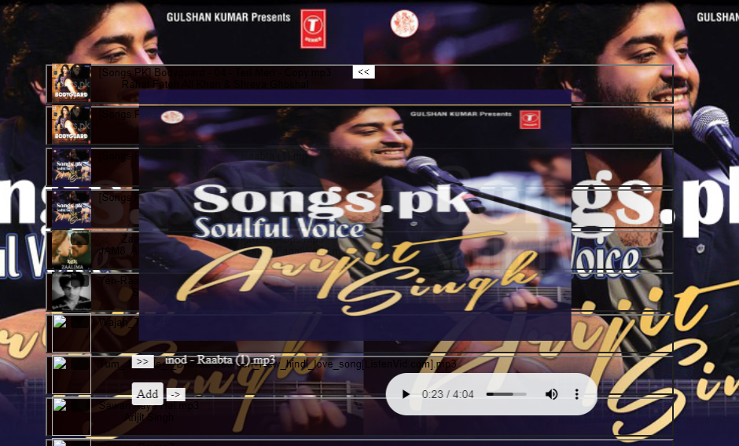

**2 With Volume Bar and Next Button:-**

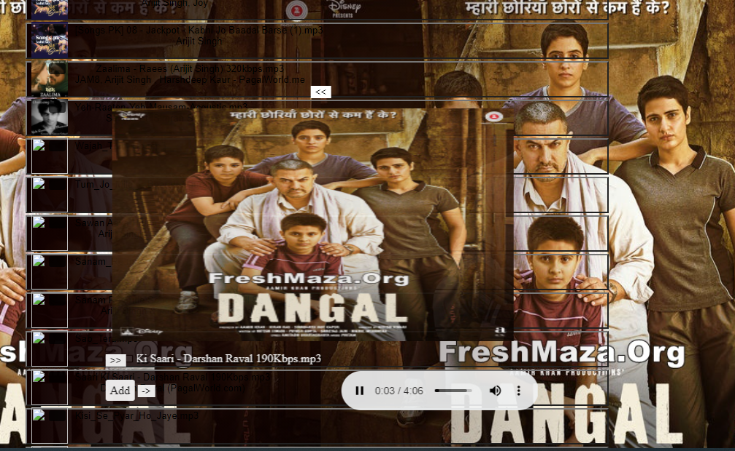

**3 With Adding New Songs in the Directory:-**

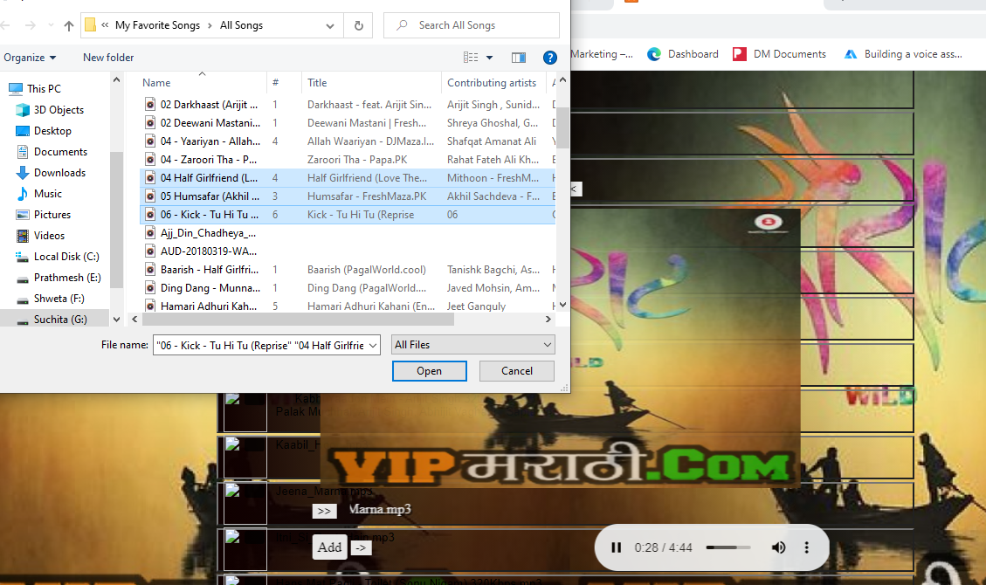

**4 With Download Option:-**

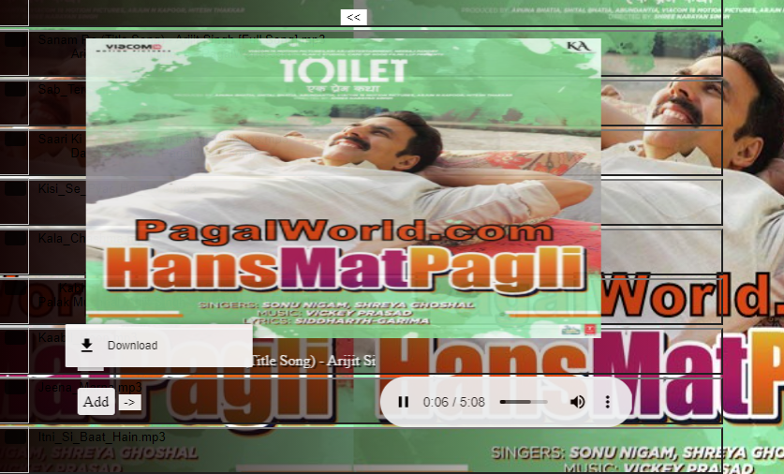

**7.0 Skills Developed/ Learning Outcomes from this Micro-Project:-**

1. Oral and written communication skills are developed.

2. Learned to work within a team and also independently.

3. Developed the skills in creating and designing the Audio Player.

4.Learned to develop PHP application.

**8.0 Benefits of Micro-Project:-**

1. This project is based on creating and developing a Audio player which is very efficient and Attractive.

2. The aim of this project is that the user should be able to navigate the application clearly, easily and in efficient manner.

**9.0 Area of Future Improvement:-**

1. Simple development of this project is, organizing the ease for people when they need any entertainment .

**10 Name of Team Members with Roll No:-**

**Name of Student Roll No**

1. Ritika Rahul Bedmutha 13501

2. Neha Shital Bhore 13502

3. Shweta Deepak Bhosale 13503